**PCOS Detection Application Manual:**

**Overview:**

The PCOS detection application allows users to determine if they have Polycystic Ovary Syndrome (PCOS) using either report data or image data, based on their preference.

**Features:**

1. Report Data Analysis: Users can manually enter their medical report data for analysis.
2. Image Data Analysis: Users can upload ultrasound images for analysis.
3. Choice of Method: Users can choose either report data analysis or image data analysis based on their convenience.

**NOTE:**

Ensure that your laptop/desktop and mobile device are connected to the internet. Use a stable internet connection for the best experience.

To access the provided web application from both a laptop/desktop and a mobile device, follow these steps:

**From a Laptop/Desktop:**

**1.Open a Web Browser:**

Launch a web browser like Google Chrome, Mozilla Firefox, Safari, or Microsoft Edge on your laptop/desktop.

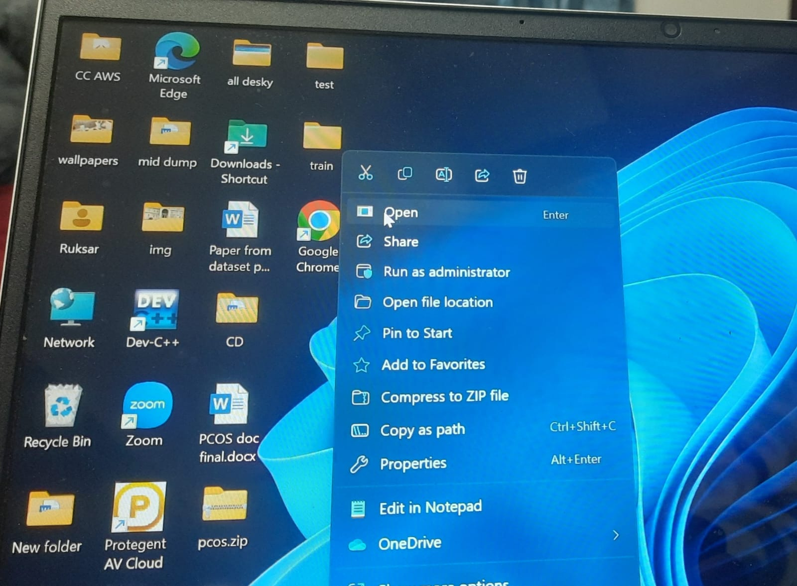

**2.Enter the Link:**

Type or paste the provided link (<https://pocs-web-app-disease-prediction-civb9sgirrkvbs87dgcva9.streamlit.app/>) into the address bar of your web browser.

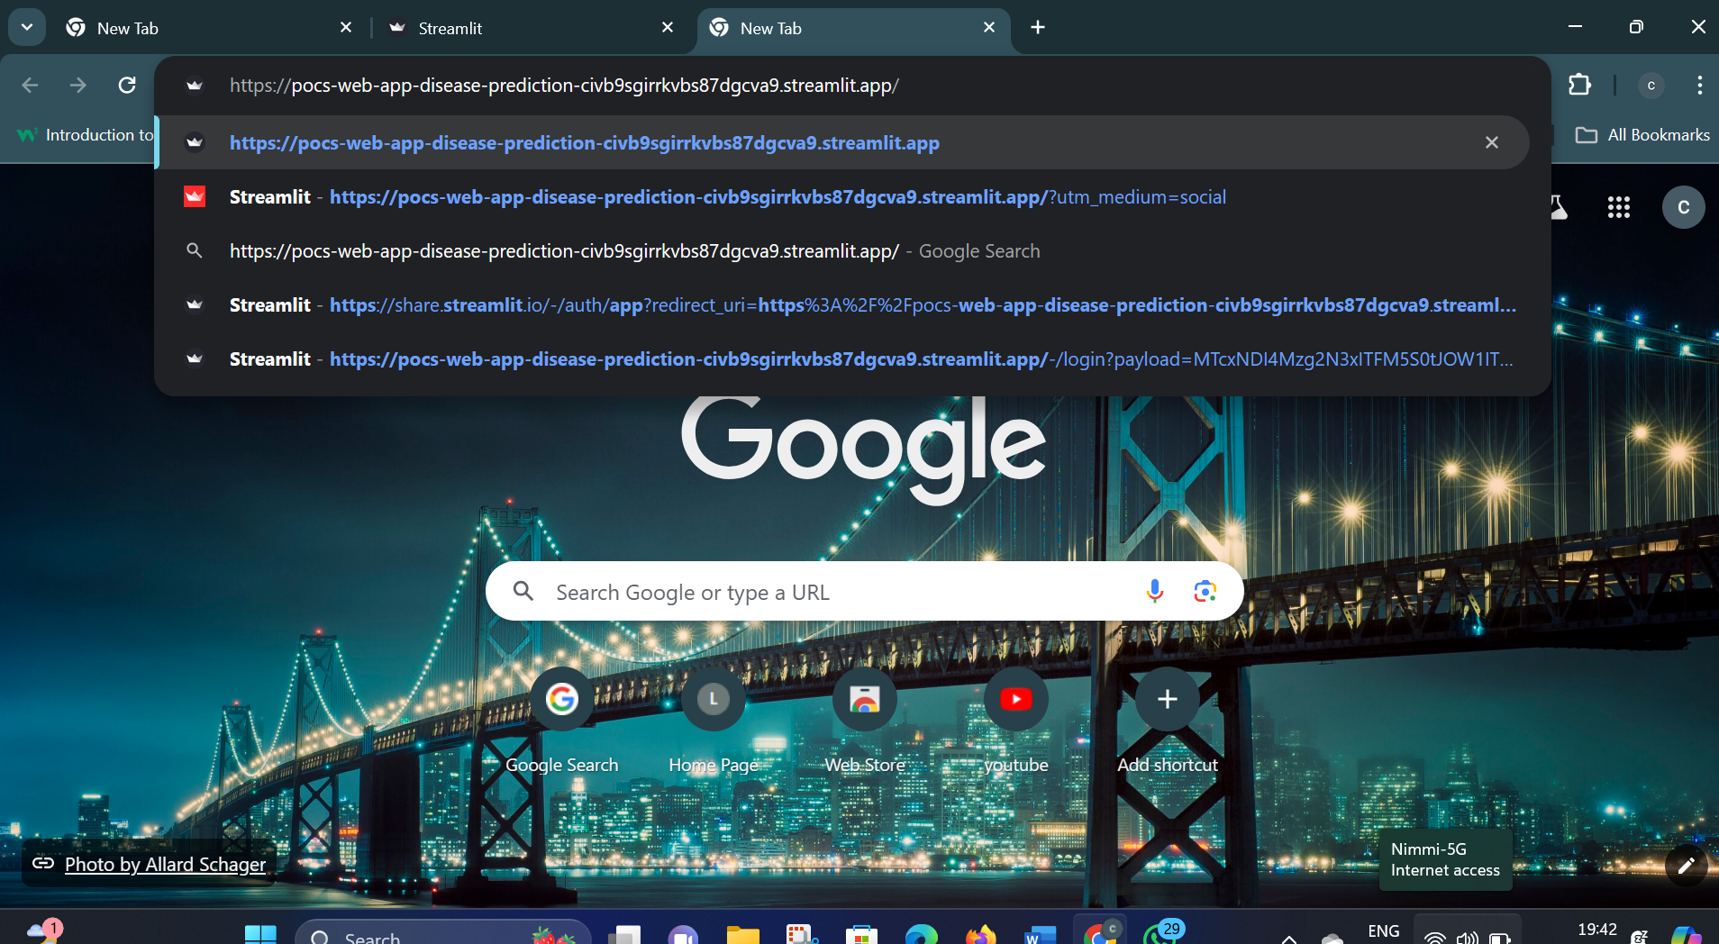

**3.Press Enter:**

Press the Enter key on your keyboard or click the Go button to navigate to the web application.

**4.Wait for the Web Application to Load:**

The web application may take a few moments to load, depending on your internet connection and the complexity of the application.

**5.Interact with the Web Application:**

Once the web application is loaded, you can interact with it using the provided interface.

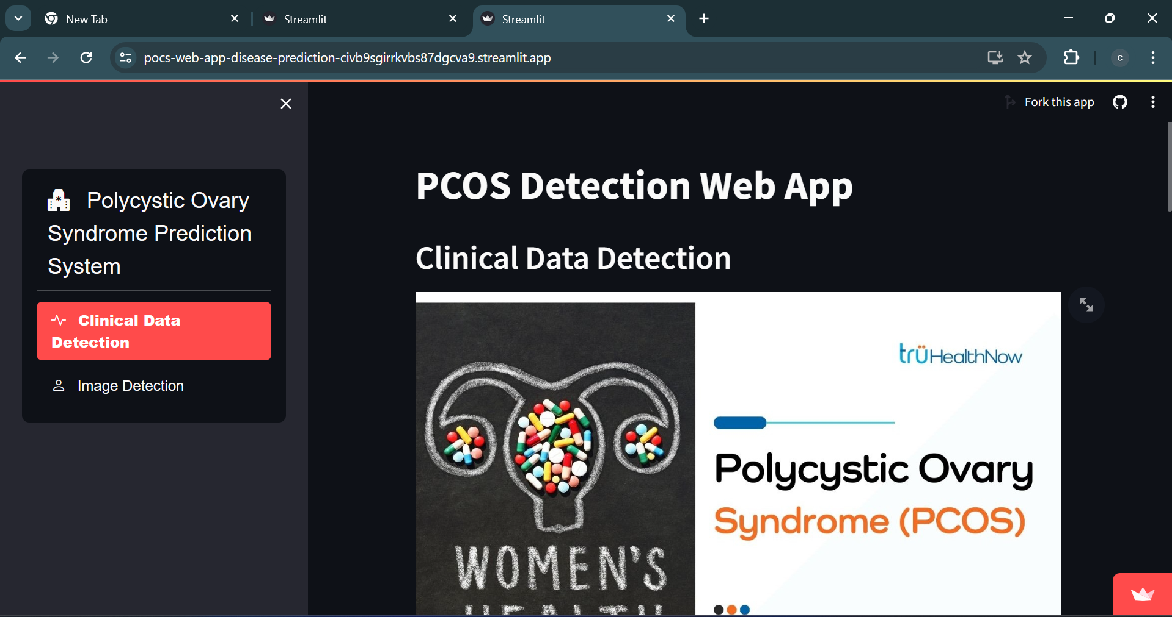

**6.Choosing the Analysis Method:**

On the home screen, select the method you want to use (Report Data or Image Data).

**7.Report Data Analysis:**

If you choose Report Data, enter your medical report using the provided interface. Click on the PCOS test result button to start the analysis process.

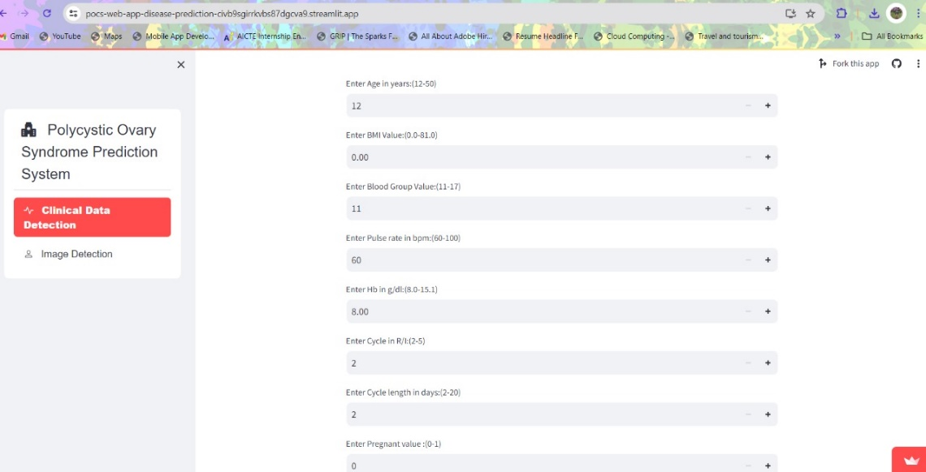

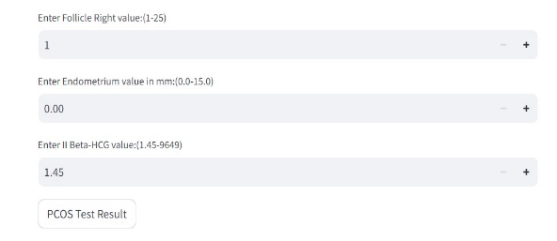

**8.Image Data Analysis:**

If you choose Image Data, upload your ultrasound image using the provided interface. You can drag and drop your files or browse it. Click on the PCOS test result button to start the analysis process.

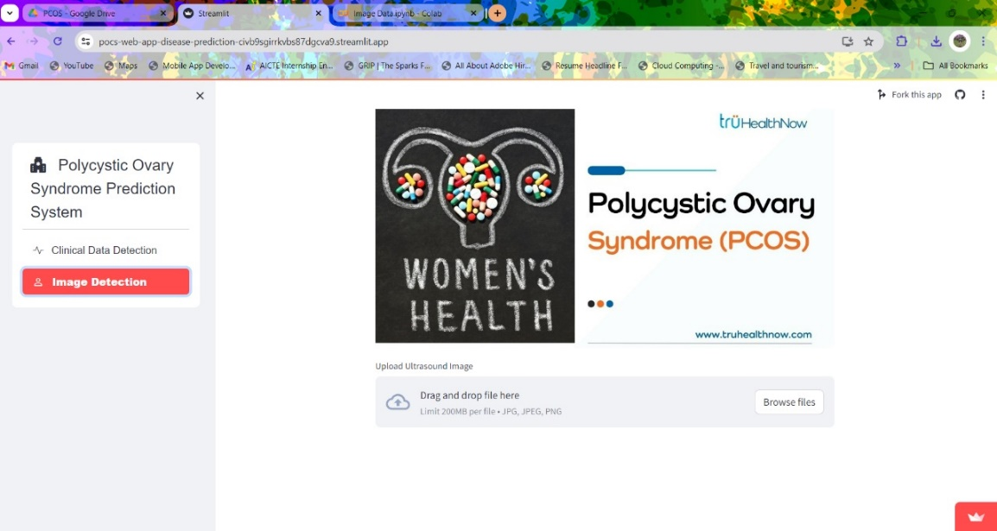

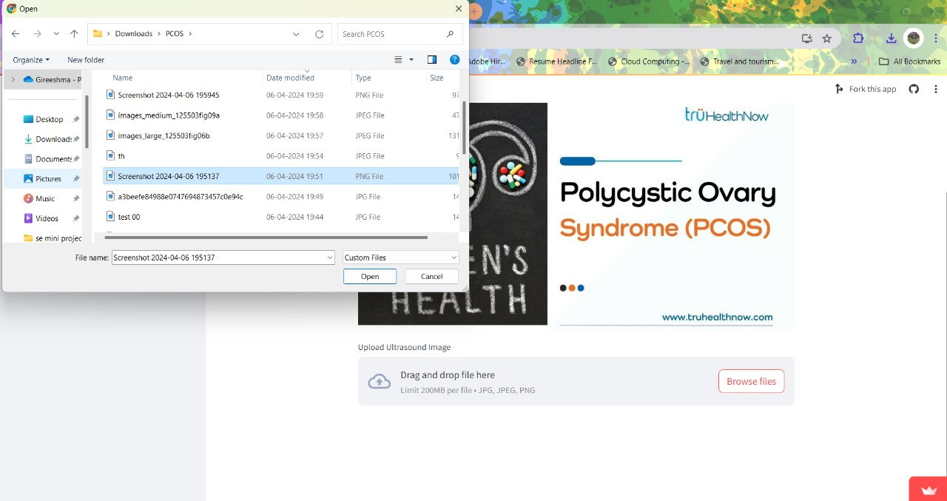

**9.Viewing the Results:**

Once the analysis is complete, the application will display the results indicating whether you are likely to have PCOS or not.

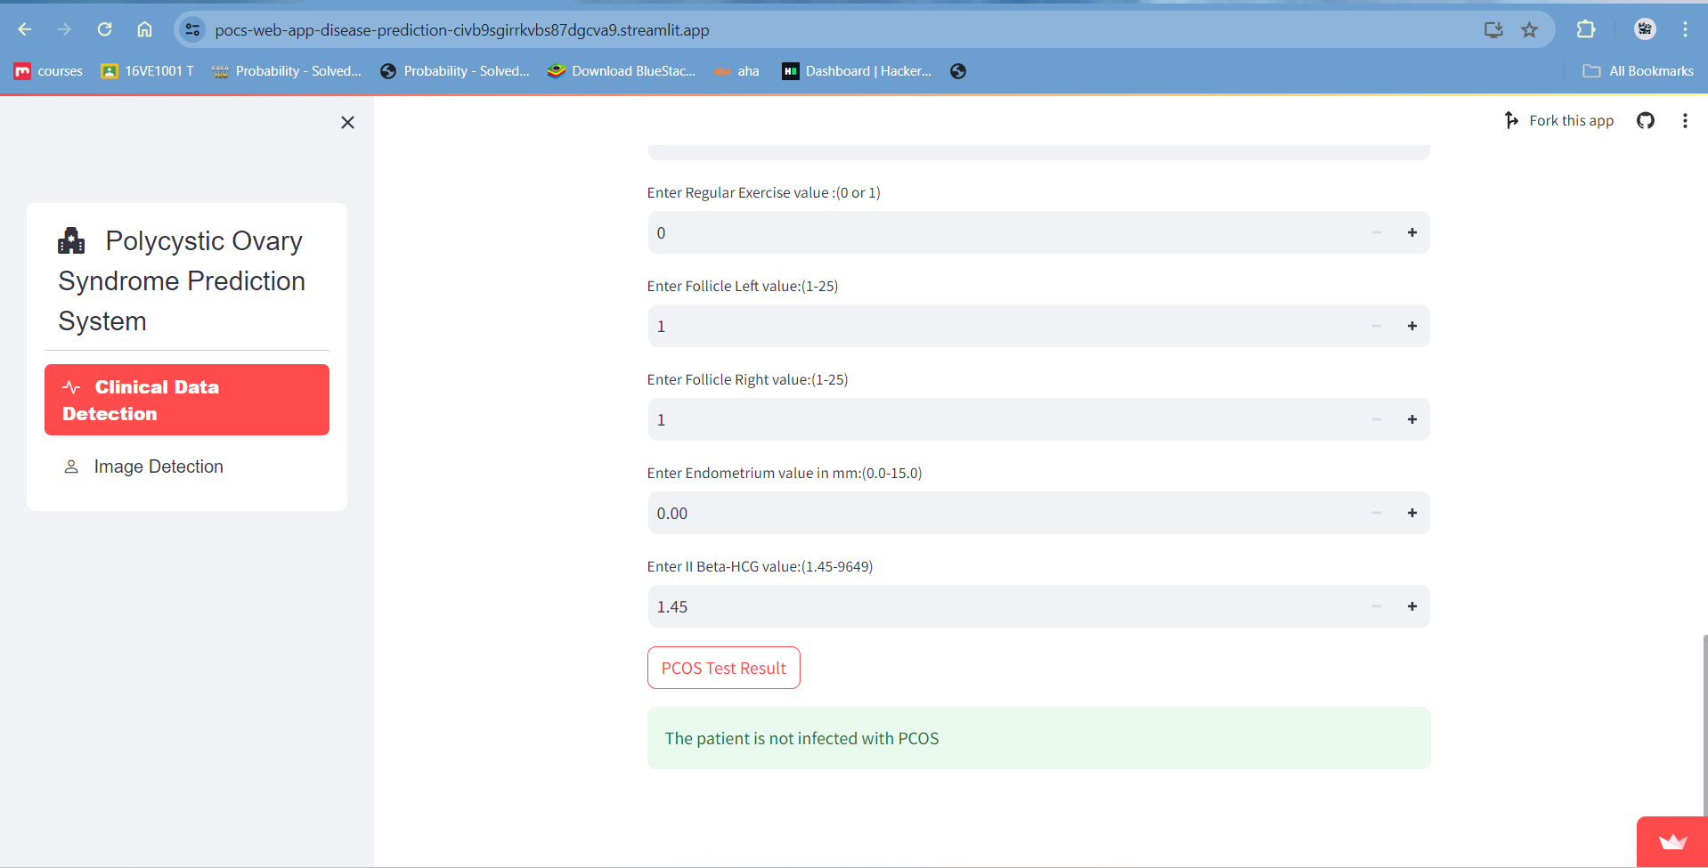

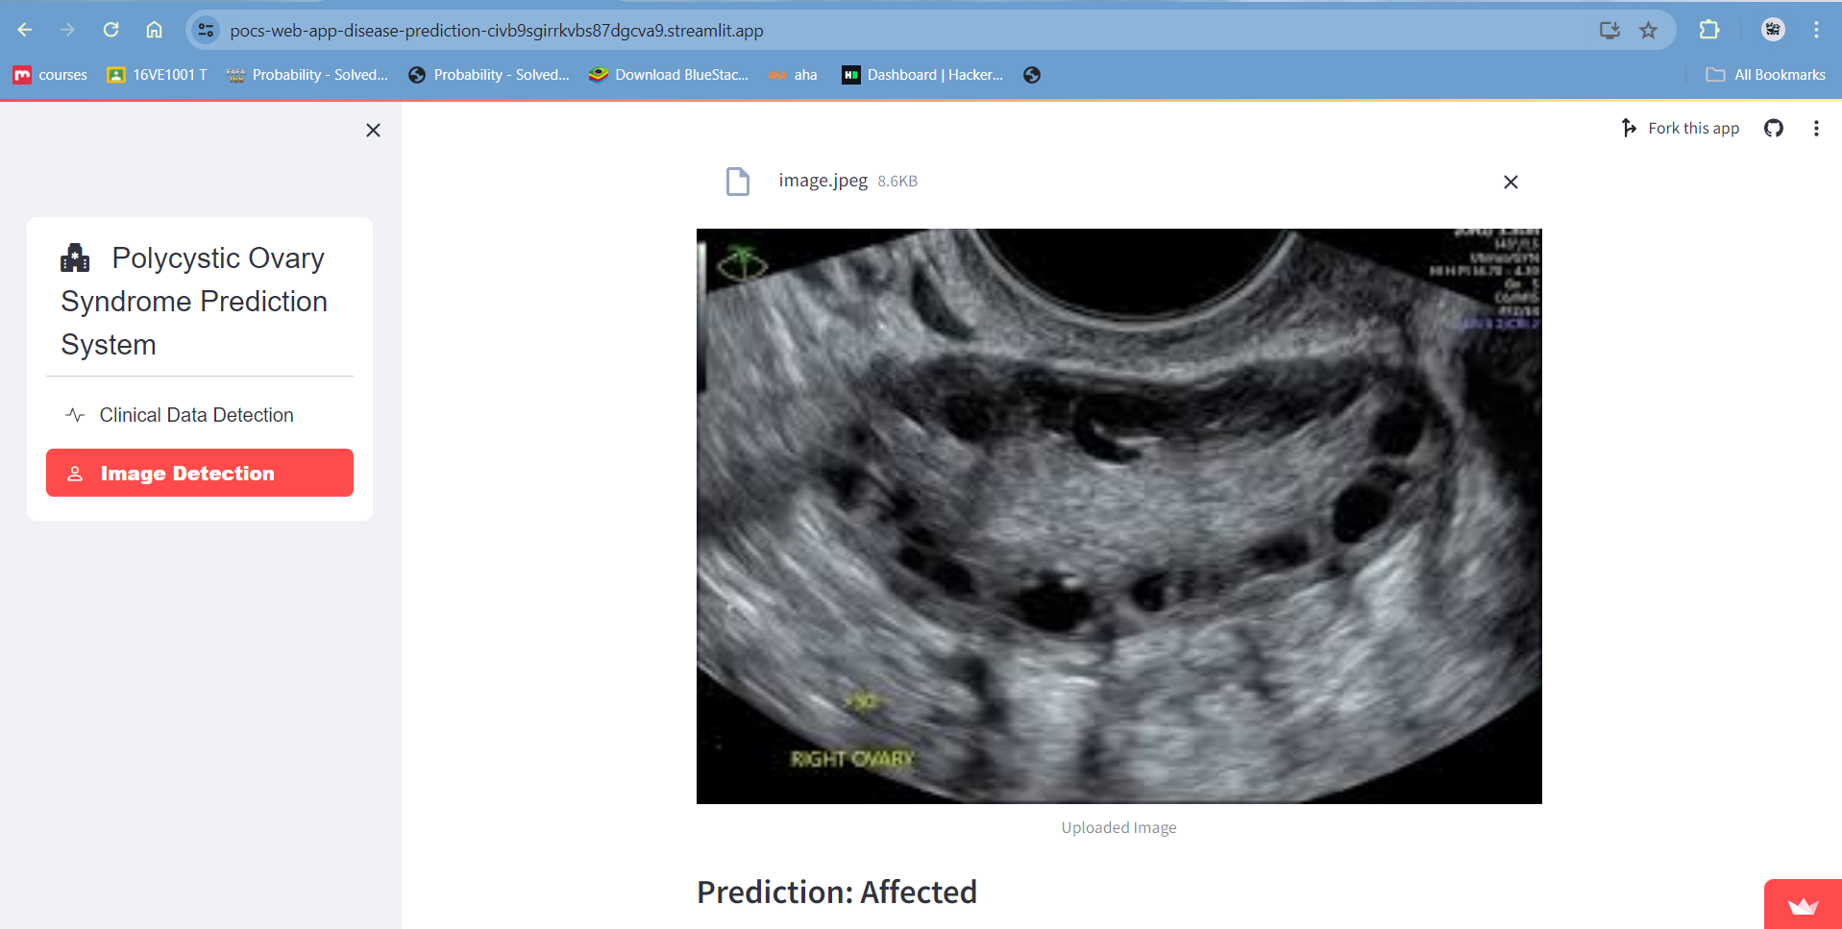

**10. Repeat Analysis (Optional):**

If you wish to analyze additional reports or images, you can repeat the process by going back to the home screen and selecting the desired method.

**11. Privacy and Data Security:**

Your uploaded data is kept secure and is only used for the analysis process.

The application complies with data protection regulations to ensure the privacy of your information.

**From a Mobile Device:**

**1.Unlock Your Mobile Device:**

Unlock your smartphone or tablet.

**2.Open a Web Browser:**

Launch a web browser app (e.g., Safari, Chrome) on your mobile device.

Enter the Link: Type or paste the following link into the address bar: <https://pocs-web-app-disease-prediction-civb9sgirrkvbs87dgcva9.streamlit.app/>

**3.Go to the Web Application:**

Tap the Go button or press Enter to navigate to the web application.

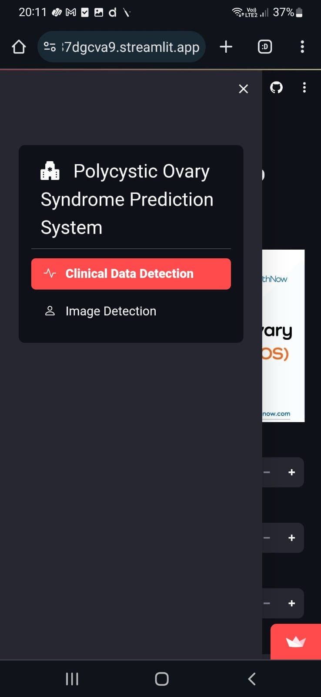

**4.Wait for the Web Application to Load:**

The web application may take a few moments to load.

**5.Interact with the Web Application:**

Once the web application is loaded, you can interact with it using the provided interface.

**6.Choosing the Analysis Method:**

On the home screen, select the method you want to use (Report Data or Image Data).

**7.Report Data Analysis:**

If you choose Report Data, enter your medical report using the provided interface. Click on the PCOS test result button to start the analysis process.

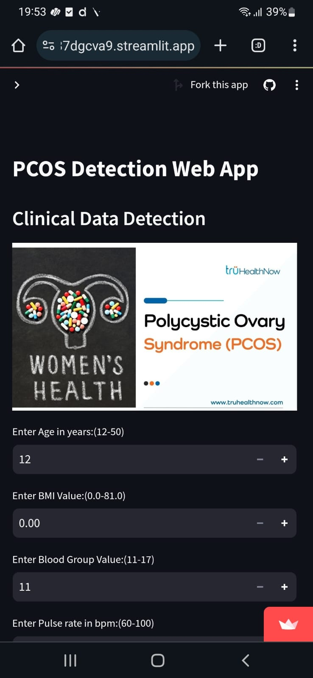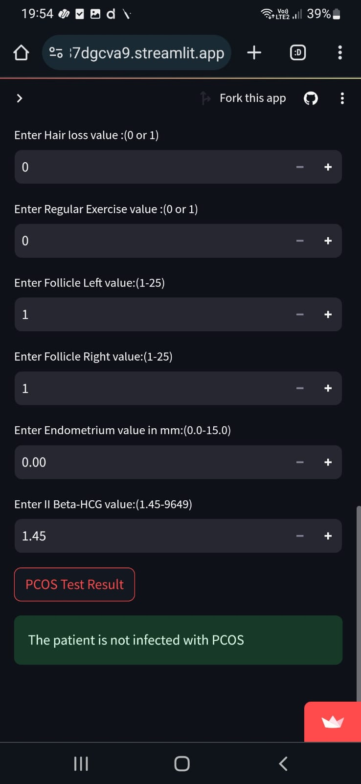

**8.Image Data Analysis:**

If you choose Image Data, upload your ultrasound image using the provided interface. You can drag and drop your files or browse it. Click on the PCOS test result button to start the analysis process.

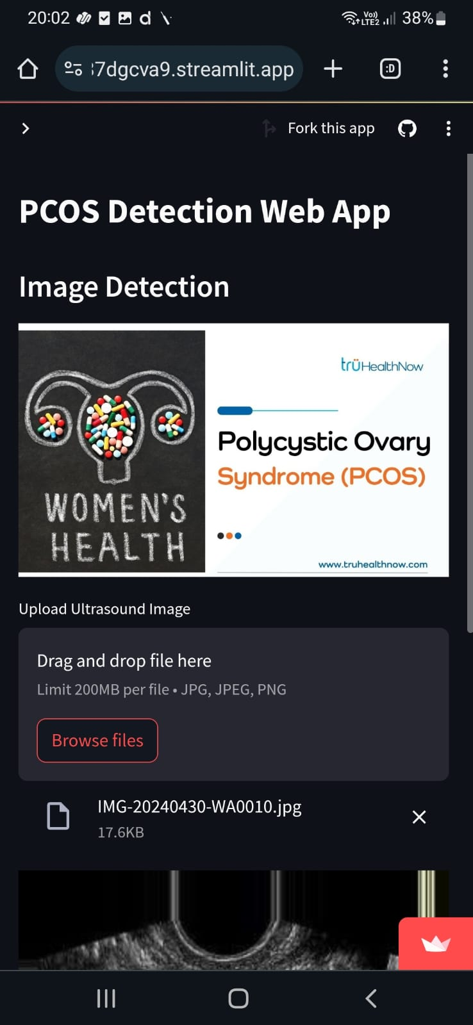 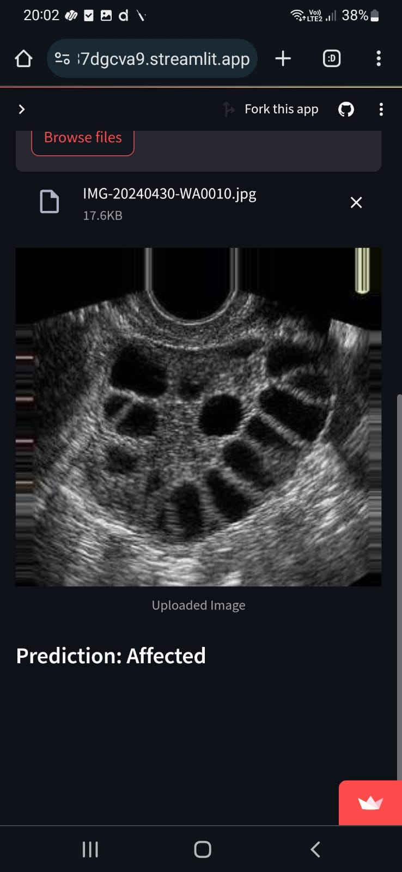

**9.Viewing the Results:**

Once the analysis is complete, the application will display the results indicating whether you are likely to have PCOS or not.

**10. Repeat Analysis (Optional):**

If you wish to analyse additional reports or images, you can repeat the process by going back to the home screen and selecting the desired method.

**11. Privacy and Data Security:**

Your uploaded data is kept secure and is only used for the analysis process.

The application complies with data protection regulations to ensure the privacy of your information.